**Enrollment:084**

**Name:Archna**

**Sol.2**

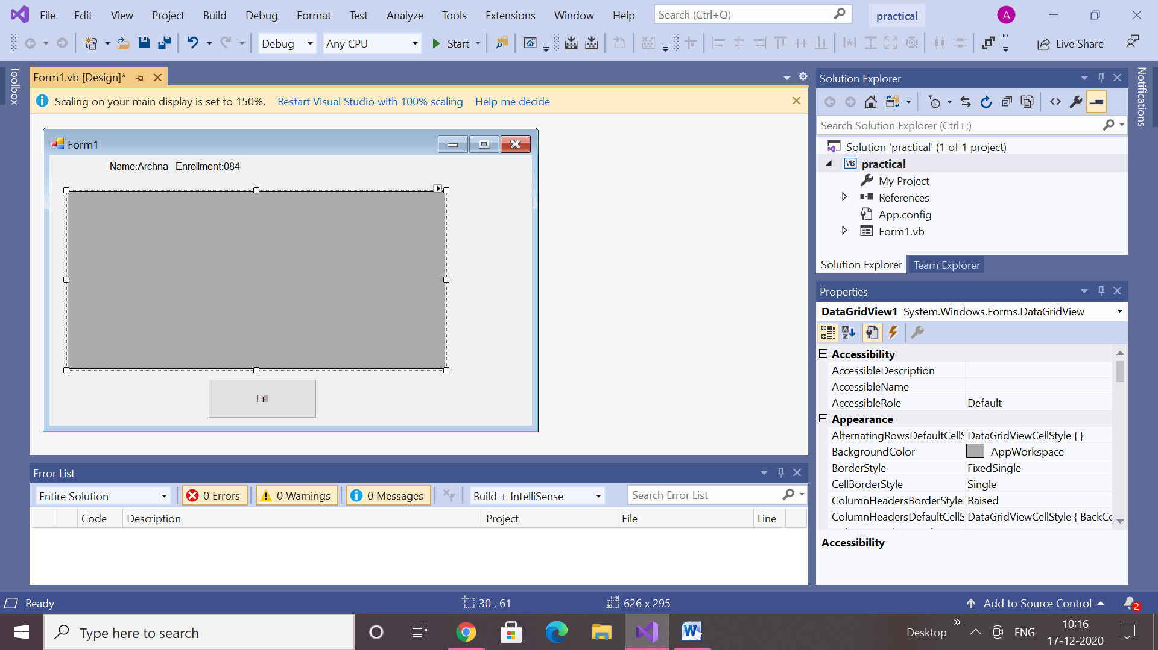

**Code:**

Imports System.Data.SqlClient

Public Class Form1

Private Sub Form1_Load(sender As Object, e As EventArgs) _

Handles MyBase.Load

Me.EmployeeTableAdapter.Fill(Me.TestDBDataSet.Employee)

End Sub

Private Sub Button1_Click(sender As Object, e As EventArgs) Handles Button1.Click

Dim connection As SqlConnection = New sqlconnection() connection.ConnectionString = "Data Source=Archna-DESKTOP; _Initial Catalog=testDB;Integrated Security=True"

connection.Open()

Dim adp As SqlDataAdapter = New SqlDataAdapter _

("select * from Employee", connection)

Dim ds As DataSet = New DataSet()

adp.Fill(ds)

DataGridView1.DataSource = ds.Tables(0)

End Sub

End Class

Output:

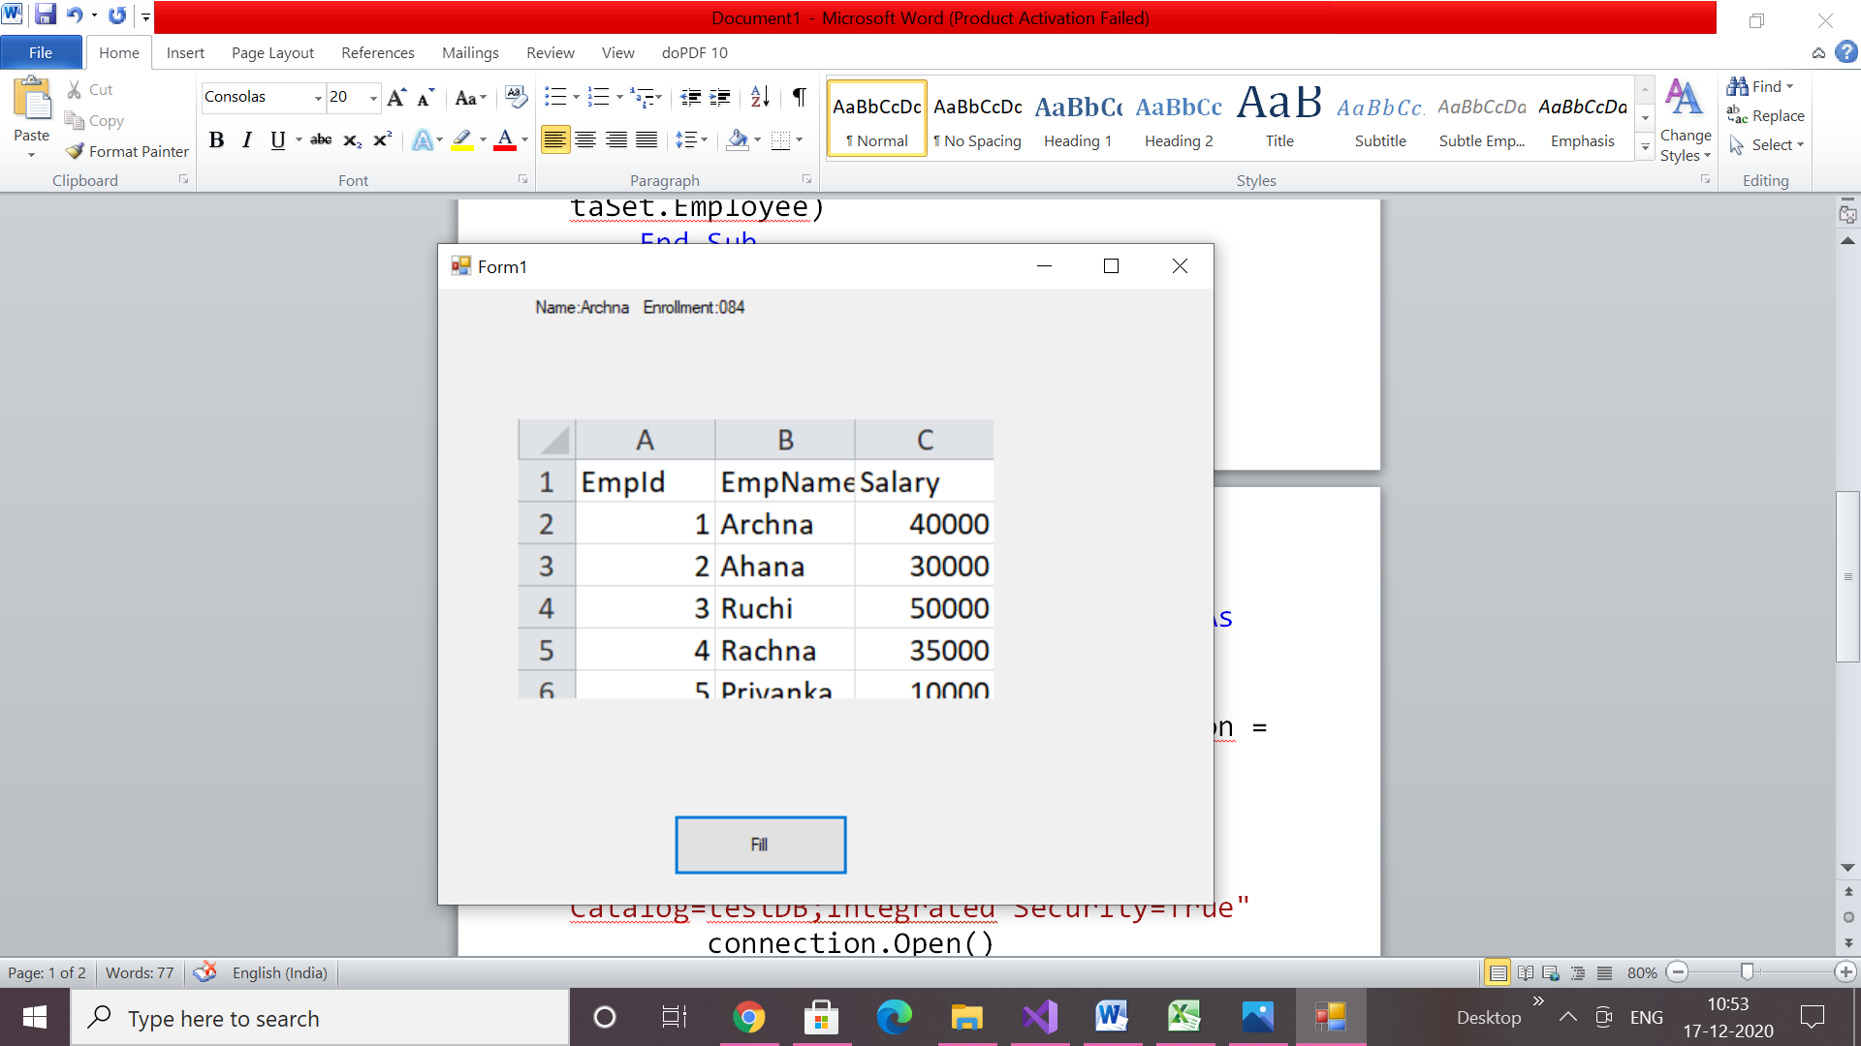

**Sol 1:**

**Code:**

Imports System.Console

Module module1

Public Class Student

Public roll As Integer

Public name As String

Public dob As Date

Public Sub get_student()

Write("Enter Name of student :")

name = ReadLine()

Write("Enter Roll Number of student :")

roll = ReadLine()

Write("Enter Date of Birth of student :")

dob = ReadLine()

End Sub

End Class

Public Class Exam

Inherits Student

Public maths As Double

Public english As Double

Public science As Double

Public computer As Double

Public accounts As Double

Public games As Double

Public Sub getmarks()

Write("Enter marks in Maths :")

maths = ReadLine()

Write("Enter marks in Science :")

science = ReadLine()

Write("Enter marks in English :")

english = ReadLine()

Write("Enter marks in Computers :")

computer = ReadLine()

Write("Enter marks in accounts :")

accounts = ReadLine()

Write("Enter marks in Games :")

games = ReadLine()

End Sub

End Class

Public Class Result

Inherits Exam

Public tm As Double

Public per As Double

Public Sub total_marks()

tm = maths + english + science + computer + accounts + games

End Sub

Public Sub percentage()

total_marks()

per = tm / 6

End Sub

Public Sub display()

WriteLine("Result of " & name & " is:")

WriteLine("Roll Number :" & roll & " Date of Birth :" & dob)

WriteLine("Marks in Games : " & games)

WriteLine(" Accounts : " & accounts)

WriteLine(" Maths : " & maths)

WriteLine(" Science : " & science)

WriteLine(" English : " & english)

WriteLine(" Computers : " & computer)

WriteLine("Total Marks are : " & tm)

WriteLine("Aggregate Percentage is :" & per)

End Sub

End Class

Sub Main()

Dim re As Result = New Result()

re.get_student()

re.getmarks()

re.total_marks()

re.percentage()

re.display()

End Sub

End Module

Output

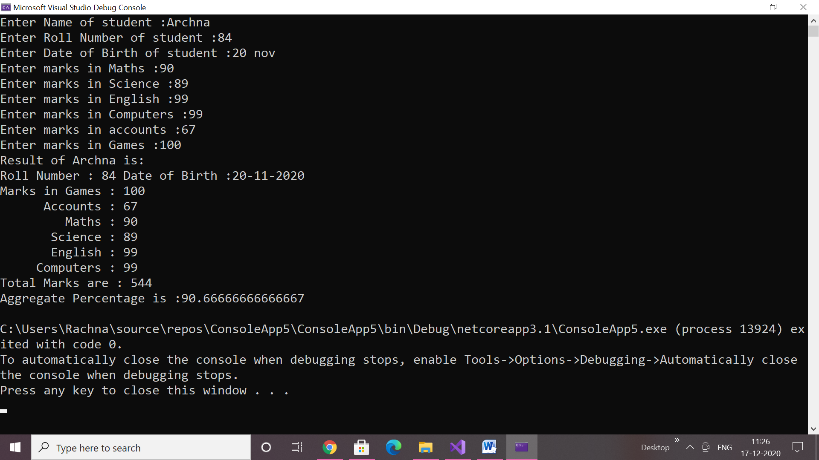

**Sol 3:**

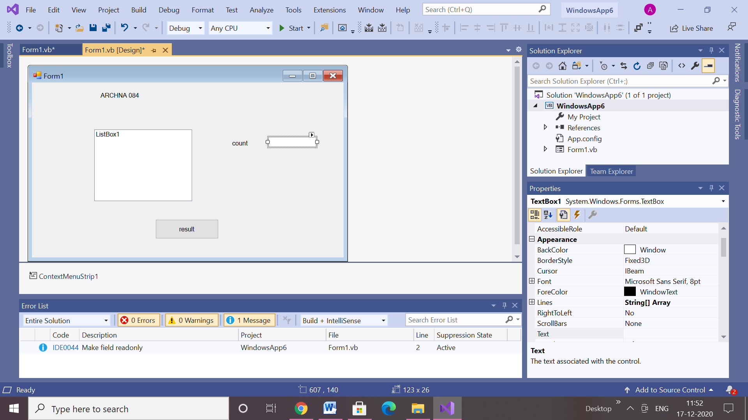

**Code:**

Public Class Form1

Dim arr As New ArrayList

Private Sub Button1_Click(sender As Object, e As EventArgs) Handles Button1.Click

Dim name As String

For a = 0 To 10 Step 1

name = InputBox("Enter name", "name", "", 500, 500)

arr.Add(name)

Next

arr.Sort()

Dim Count As Integer = 0

Dim firstElement As String

For a = 0 To arr.Count - 1 Step 1

firstElement = arr(a).Substring(0, 1)

If firstElement = "A" Or firstElement = "a" Then

Count += 1

End If

Next

TextBox1.Text = Count

ListBox.Text=arr

End Sub

End Class

**Output:**

